Abellera, Joshua Beaver Q.

Menese, James Joash F.

Machine Problem (Python): Problem 5

Python Script

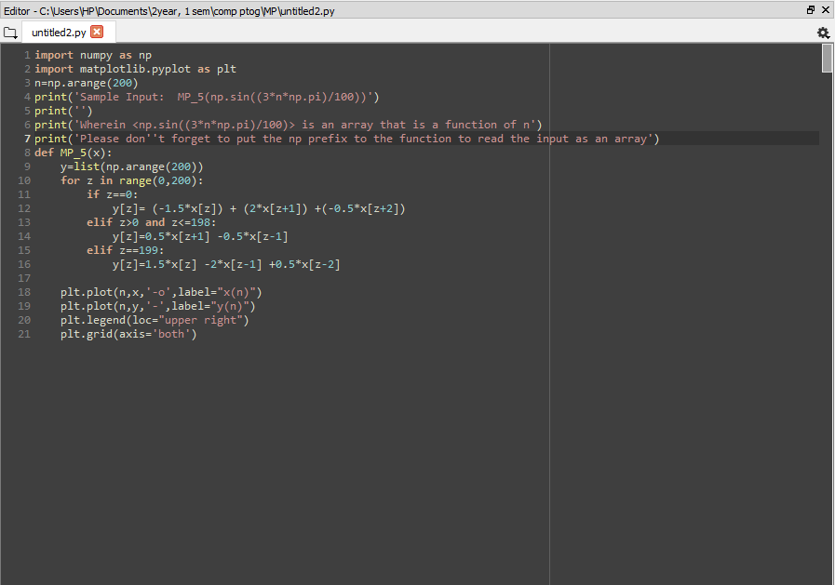

Testing the function $x\left(n\right)=sin⁡(\frac{3π}{100}n)$ 